In this section, we present three different approaches to conducting a sensitivity analysis for Option D:

* Local One-step-at-a-time (OAT) sampling analysis
* Global OAT screening method
* Global Regression based analysis

# I. Various Sensitivity Analysis Methods

## CASE A- New Construction of a Medium Office

### 1. Situation

This example involves the new construction of a medium office building in San Francisco, CA. The sensitivity of the following building characteristics is unknown and will be characterized with respect to whole building Electric Energy Use Intensity (EUI):

* Window to Wall Ratio (WWR)
* Lighting Power Density (LPD)
* Space Infiltration

### 2. Building Modeling and Analysis Tools

For this example, the OpenStudio[1] (OS) tool chain will be used since it is free and open source. Building Energy Models (BEM) created in the OpenStudio format (.osm) can easily be manipulated by OpenStudio Measures[2], which are a set of programmatic instructions that makes changes to an energy model to reflect its application. This concept of creating and manipulating energy models through Measures will allow us to turn building characteristics into Explanatory Variables and determine their sensitivity in a way that is consistent, scalable and easily shared with co-workers, clients or the general public.

The *Medium Office* from the DOE Commercial Prototype Building Models[3] will serve as our example building and the energy model will be programmatically generated by using the OpenStudio Prototype Buildings Measure[4]. This has the advantage that the reader can easily reproduce the workflow and results shown in this section, however a user defined energy model can easily be created by modifying the energy model created by the OS Prototype Measure or by building a model from scratch using the OpenStudio Application.

The sensitivity analyses presented utilize the OpenStudio Analysis Framework, consisting of the OpenStudio Analysis Spreadsheet[5] for problem definition and the cloud computing capabilities of OpenStudio Server[6] for algorithm implementation and simulation runs. Both of these tools are free to use, however the actual cloud computing time from Amazon must be purchased from a user specific Amazon EC2 account.

### 3. Energy Model and Variable Characterization

The energy model for this example is created by using the following inputs in the Prototype Building Measure:

* Building Type: Medium Office
* Vintage: 90.1-2010
* Climate Zone: ASHRAE 169-2006-3C

This results in a building that is *typical* of a new construction, medium office building in San Francisco, CA and is depicted in Figure 1.

Figure 1: Medium Office Prototype Building

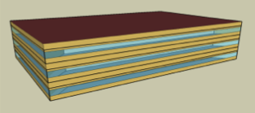

The building characteristics of Window to Wall Ratio, Lighting Power Density and Space Infiltration will be altered by using OpenStudio Measures that specifically manipulate those values in the energy model. The actual OpenStudio Measures used in this example, along with the code used in this analysis can be downloaded from (XXX). To understand the effect that these parameters have on building electric EUI, we first need to define valid ranges (minimum and maximum) and distributions (triangular, uniform, etc) for each input, thus turning our building parameters into Explanatory Variables.

For this example, triangular distributions were chosen for each Explanatory Variable and are depicted in Figures 2-4 with the ranges listed in Table 1. Ranges for each Explanatory Variable are typically defined by project constraints or best practices. It should be noted that while the plotted distributions do not appear to be triangles, that is just an artifact of plotting them using histogram and curve fit functions in R.

Table 1: Explanatory Variable Ranges

|  |  |  |  |
| --- | --- | --- | --- |
| Variable | | Minimum | Maximum |
|
| Lighting Power Reduction (W/ft2) | 0.2 | | 1 |
| Window to Wall Ratio (fraction) | 0.2 | | 0.4 |
| Space Infiltration (% change) | -30 | | 30 |

The distributions for LPD and WWR specify actual parameter values while the distribution for Space Infiltration represents a percent change from the baseline model. This is done to be consistent with how each OpenStudio Measure interacts with each Explanatory Variable. The OpenStudio Measures for LPD and WWR apply an actual value of these parameters to the model, while the Space Infiltration Measure applies a percent change to the baseline models value. Some projects like to deal with absolutes, while others like to deal with percent changes. Neither way is incorrect, however, care must be taken to be aware and consistent with how each OpenStudio Measure operates.

Figure 2: Lighting Power Density Distribution

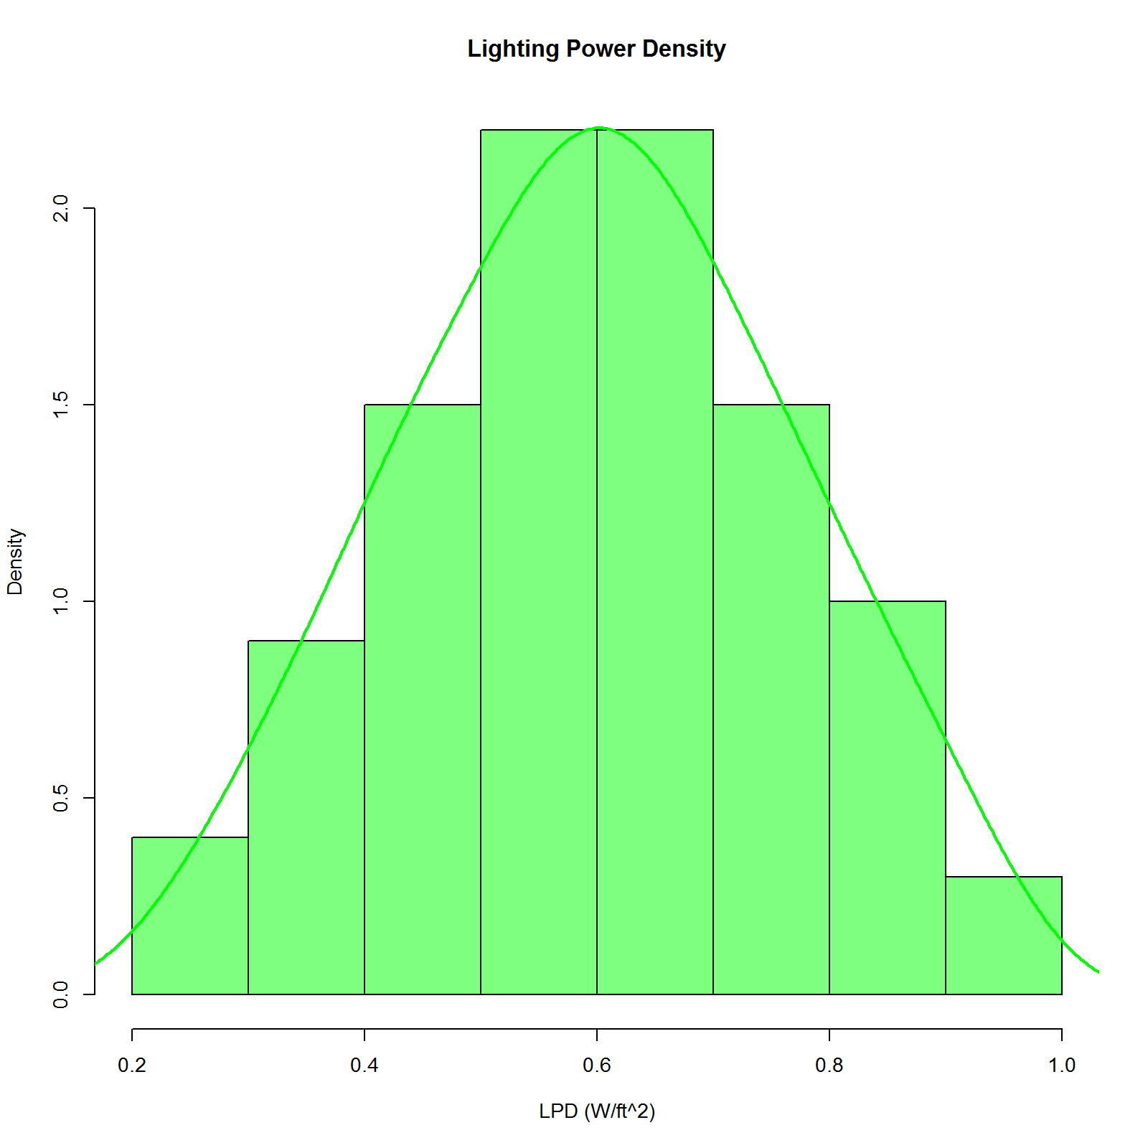

Figure 3: Space Infiltration Percent Change Distribution

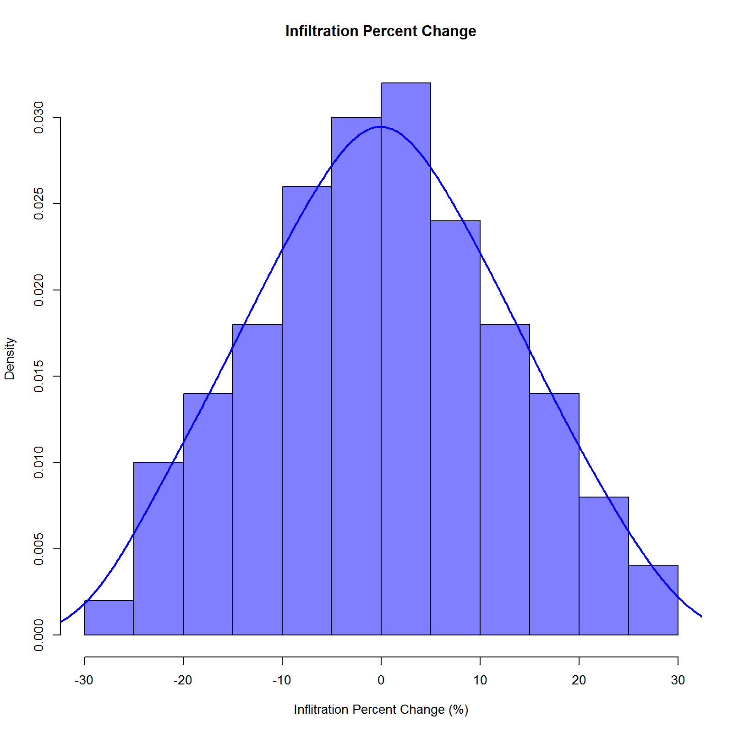

Figure 4: Window to Wall Ratio

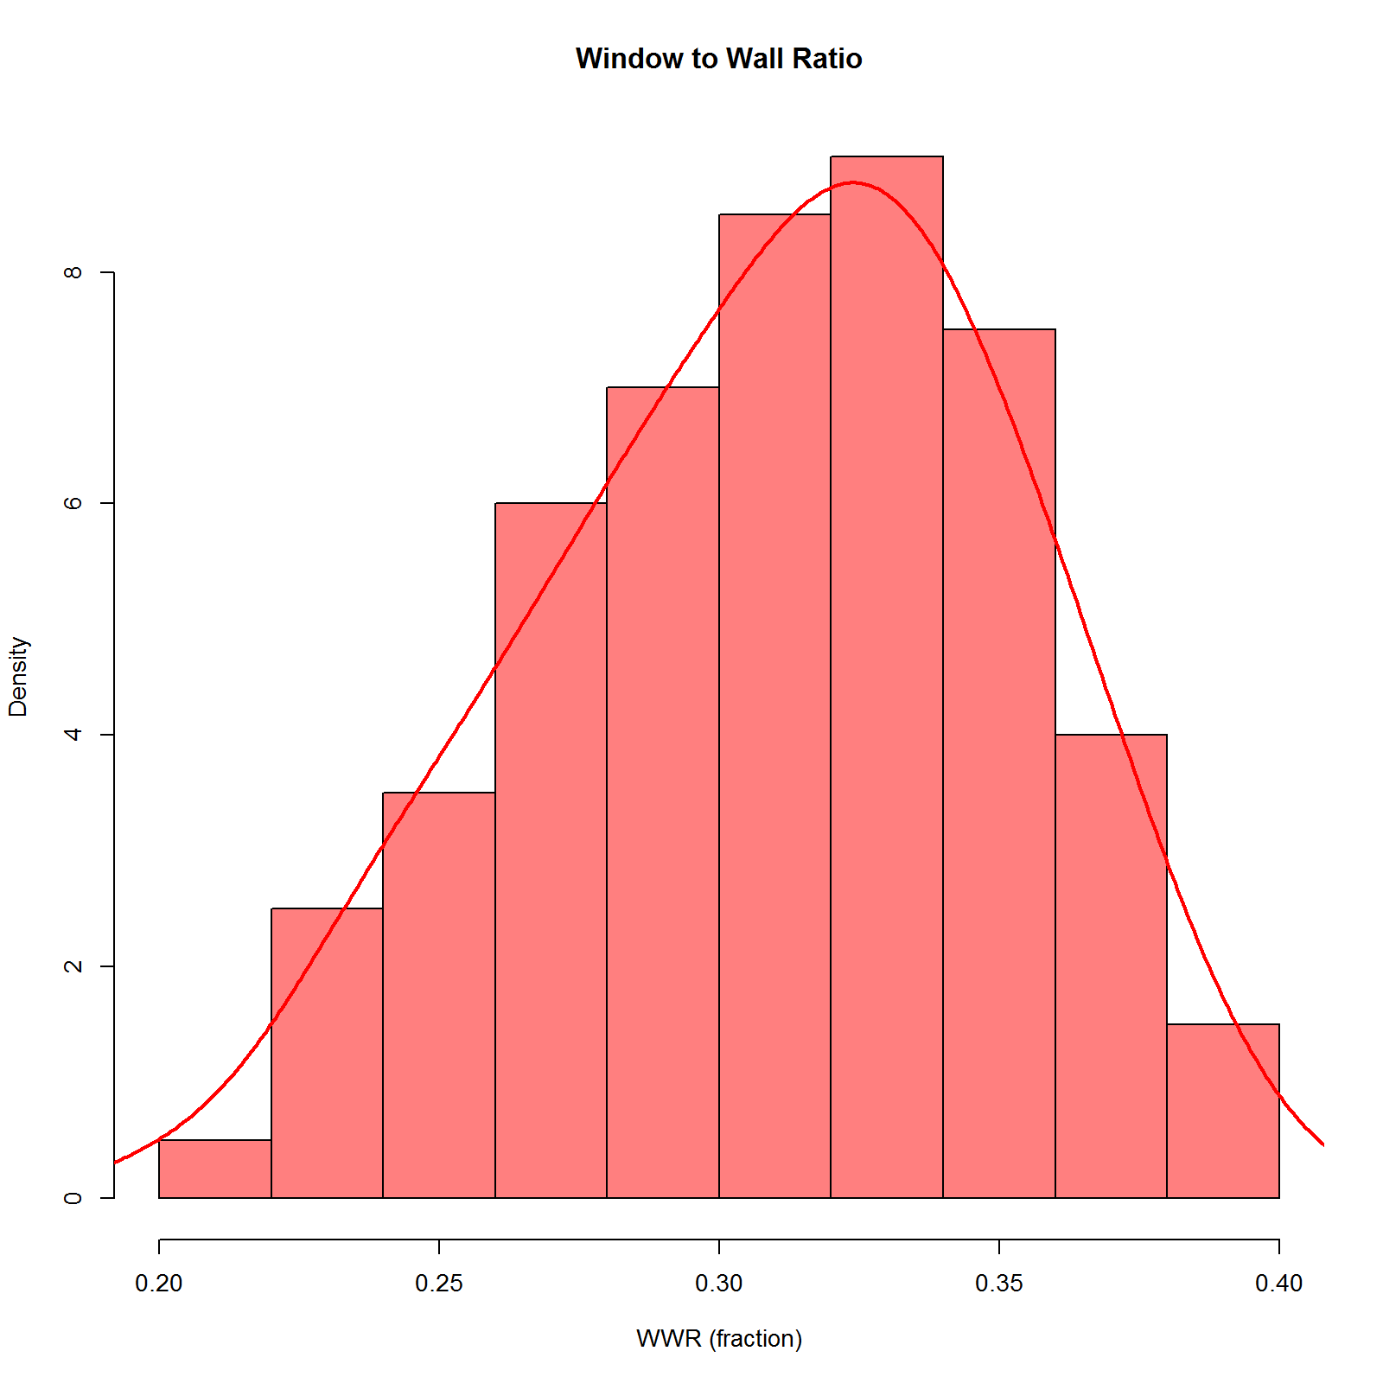

### 4. Local One-step-at-a-time (OAT) sampling analysis

Latin Hypercube Sampling[7] (LHS) is a method of sampling that attempts to distribute samples evenly over the sample space and can be applied to multiple variables or dimensions. The method essentially divides the distribution to be sampled into areas of equal probability and puts an equal number of points into each area. This has the effect of giving a more even sampling across a distribution with fewer points compared to a purely random sample.

Using the OpenStudio Analysis Workflow we will sample the three Explanatory Variables, one at a time, while holding the others Variables constant (at their default values) resulting in a one-at-a-time (OAT) sampling method. This method is also described as a local method since we are holding all the non-sampled Explanatory Variables to their default values. Thus, while we are getting some sense of the effect of the perturbed Variable, this perturbation is only with respect to the same locally fixed values for the other Variables. The details on how to accomplish this can be found in the user guide for the OpenStudio Analysis Spreadsheet[8] and the actual spreadsheet used in this example can be found here. The number of samples used in the LHS method should be chosen following guidance as detailed in Section (XX). For cleaner illustrations, the number of samples in this example for each variable was chosen to be 100. This resulted in a total of 300 simulations to run and the solution space is depicted in the parallel coordinates plot in Figure 5. The first three coordinates are the Explanatory Variables: Space Infiltration, LPD and WWR. The fourth coordinate is the Dependent Variable Electric EUI.

To visually estimate the relative sensitivity of each Explanatory Variable, we can restrict the parallel coordinates plot to display the results of only one of the sampled Variables at a time and examine the resulting spread in the Electric EUI. This is depicted in Figures 6-8 for the Explanatory Variables: Space Infiltration reduction, LPD and WWR respectively.

Figure 5: LHS OAT Solution Space

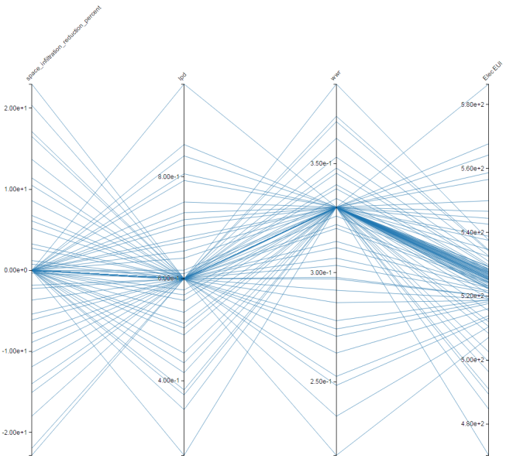

Figure 6: Space Infiltration Reduction. Smallest variation in Electric EUI

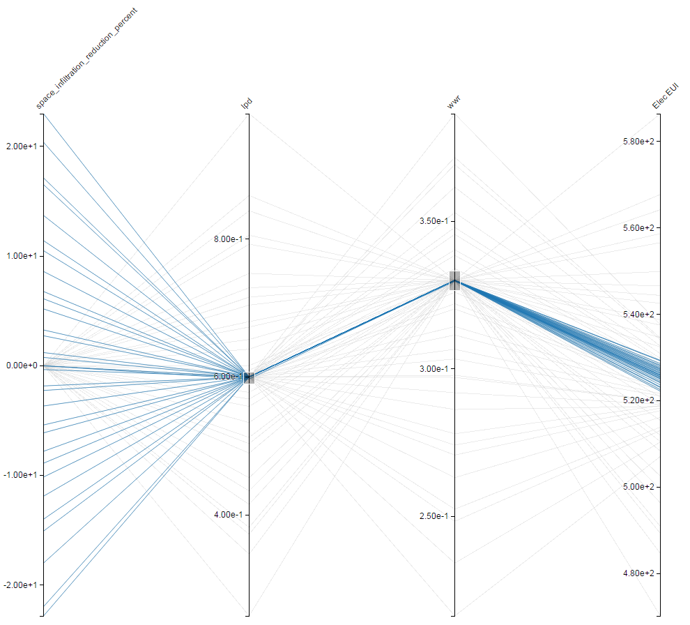

Figure 7: LPD. Largest variation in Electric EUI

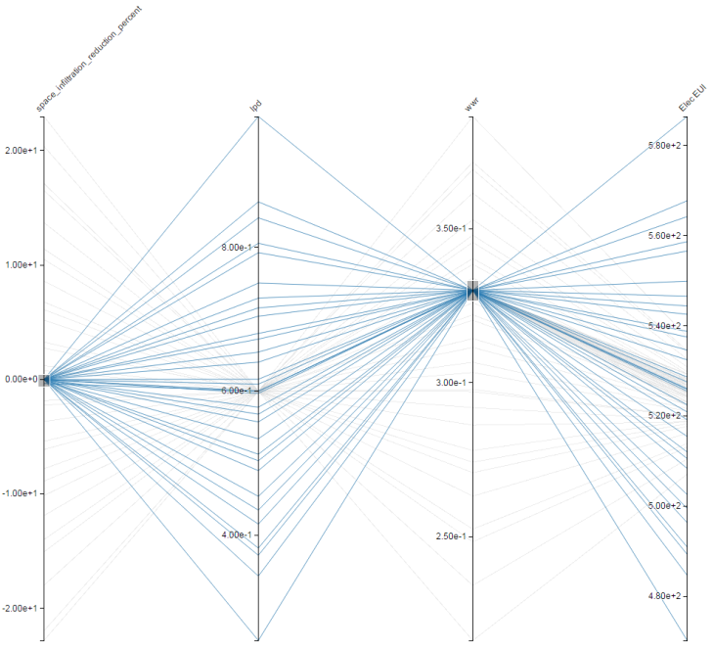

Figure 8: WWR. Medium variation in Electric EUI

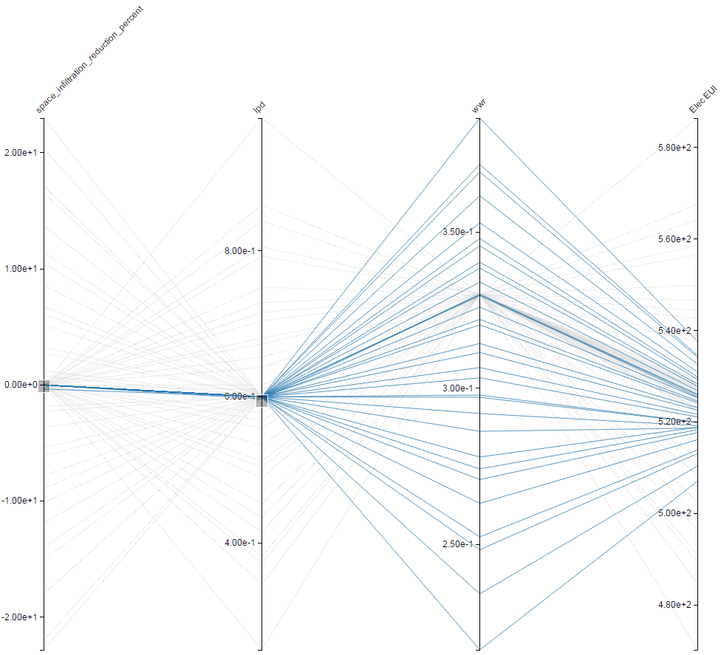

While this method only provides a visual estimation of the Explanatory Variable sensitives, it is nonetheless very powerful and instructive. From Figures 6-8 it is clear that LPD is the most sensitive with respect to Electric EUI, followed by WWR and then Space Infiltration.

This visual inspection can be followed up by overlaying the resulting histograms of Electric EUI variation due to the variation in the Explanatory Variables which is depicted in Figure 9. The sensitivity of each Explanatory Variable on Electric EUI can be determined by looking at the support or base width of each colored distribution. For example, the green distribution is the Electric EUI variation resulting from the distribution of LPD given in Figure 2. The blue distribution is the Electric EUI variation resulting from the distribution of Space Infiltration Percent Change in Figure 3 and so on. It should be noted that the height of the distributions are such that the area under the distribution equals one, resulting in each being a probability distribution.

Figure 9: Electric EUI Variation due to Explanatory Variables

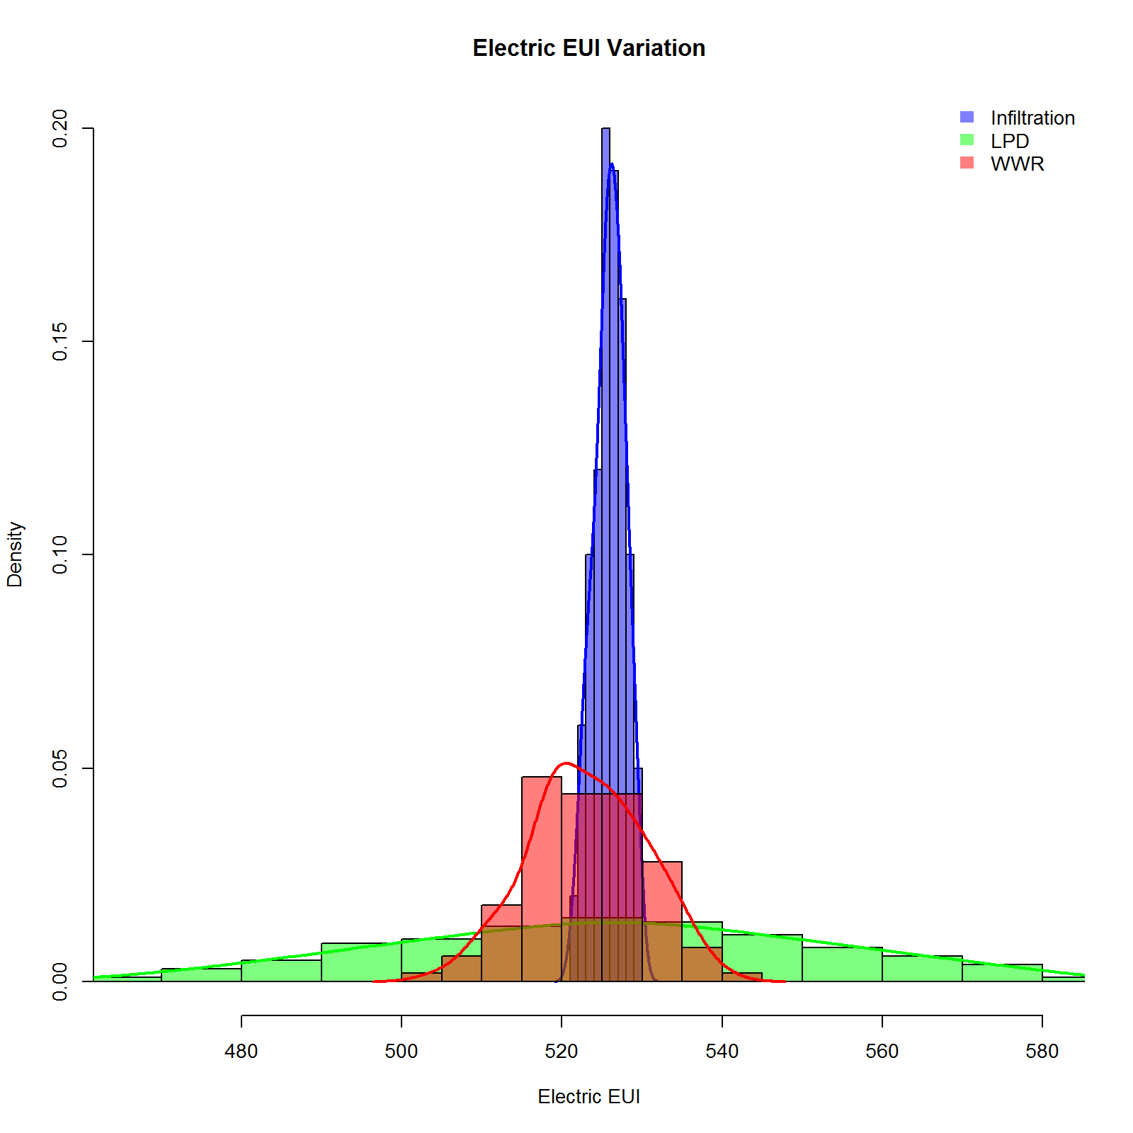

### 5. Global OAT screening method

To gain a more qualitative assessment of the sensitivity of each Explanatory Variable, we will use the Morris OAT Method[9]. Morris’s elementary effects screening method identifies the few important factors or elementary effects at a cost of r × (p + 1) simulations (where *p* is the number of factors and *r* is the number of elementary effect computed per factor). The Morris Method implementation used in the OpenStudio Server comes from the R package *Sensitivity,* which includes improvements to the original method defined by Morris, specifically a space-filling optimization of the design[10] and a simplex-based design[11].

The *r* value for this example was set to 10 resulting in a total number of 40 simulations. The resulting sampling pattern of the solution space is plotted in Figure 10. Since *r* was set to 10 for this example, there will be 10 calculations of the Elementary Effects (EE) for the Explanatory Variables, with each one coming from a *different initial condition* in the solution space depicted in Figure 10, thus making the method more global in nature.

Figure 10: Sampling pattern for Morris Method

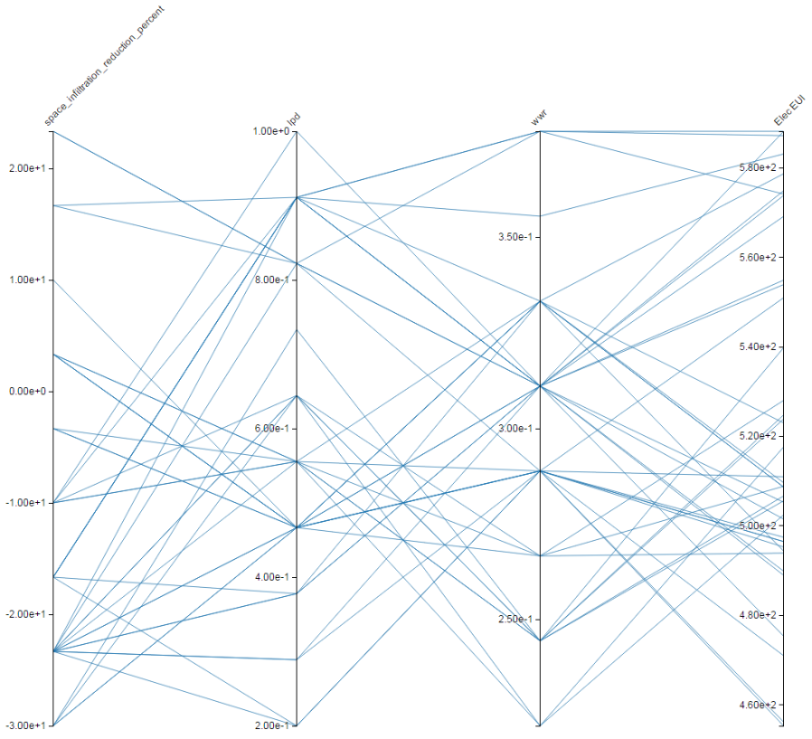

The main output of the Morris Method is the mean and standard deviation of the EEs for each Explanatory Variable. In this example, the 10 EEs are averaged and the standard deviation is computed and denoted Mu and Sigma respectively. It is typical to take the absolute value of the Elementary Effects before averaging to eliminate any possible canceling of values if the EE results are both positive and negative. This is the typical output value for the Morris Method and is denoted Mu* or Mu Star along with the value of Sigma which characterizes the variation of the EEs. A low value of Sigma typically means the EE value is relatively consistent and that there is negligible interaction with other possible factors or Explanatory Variables. A higher Sigma value typically means the EE value is not consistent and there could be nonlinear effects at play and/or there are possible interactive effects with other factors or Variables.

The Mu Star values for our example are plotted in Figure 11. It is noted that these values are consistent with the results of the LHS OAT method previously described, however the results were computed with fewer simulations and the sensitivities are global for the Morris Method, rather than local as was computed with the LHS OAT method. Like all screening methods, the Morris Method provides qualitative sensitivity measures which allows us to rank the Explanatory Variable in order of importance, but do not quantify exactly the relative importance of the inputs. This means we can only compare and rank results from this example to itself and does not directly translate to other examples or projects.

Figure 11: Average value of Elementary Effects from Morris Method

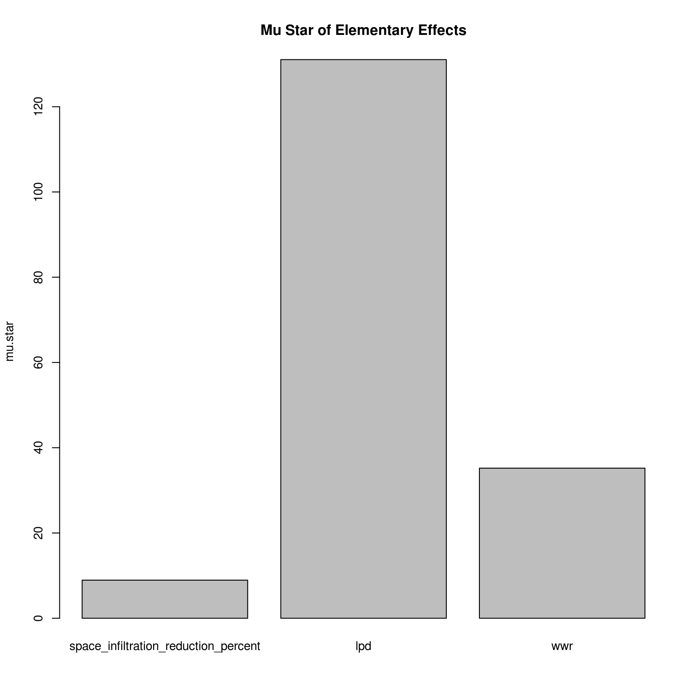

### 6. Global Regression based analysis

In this section, we attempt to estimate the sensitivities of the Explanatory Variables by constructing a multi-variable linear model. The model we propose is as follows:

Equation:

In this model, the slope or beta coefficients (except the intercept ) are a measure of the sensitivity of each Variable. As we saw in the previous two methods, LPD had a larger effect on the Electric EUI than WWR, thus in this equation we would expect to be larger than . In fact, we expect that since Space Infiltration had the smallest effect on Electric EUI. To create the data necessary to examine such a model, we will again resort to using LHS, however this time we will **not** do a OAT method but instead sample **all** the Explanatory Variables at the **same** time. For illustrative purposes, we will use 400 as the sample size with the resulting solution space depicted in Figure 12. This solution space is much denser than the OAT LHS sampling depicted in Figure 5.

Figure 12: LHS non-OAT Solution Space

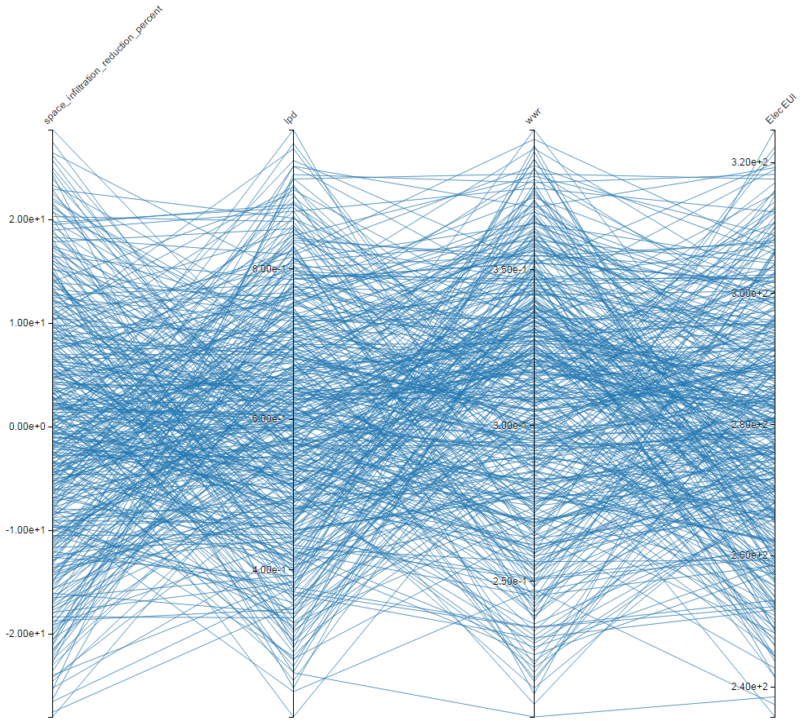

After running the 400 samples using OS Server, an R data frame of the data can easily be obtained by clicking the *download R data frame (Results)* button on OS Server as depicted in Figure 13. To do the linear regression, we use the *lm* function in R. The results of the linear regression are listed in Tables 2-3. As detailed in Chapter (XXX), the results of Table 3 suggest the linear regression is a good fit to the data and the sensitivities or slopes for each Variable align with the results of the previous methods.

Figure 13: Download R dataframe from OS Server

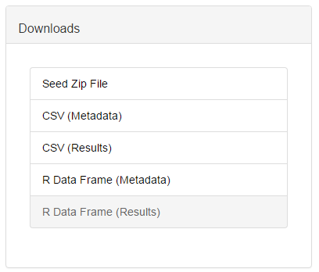

Table 2: Linear Regression Coefficients

|  |  |  |  |
| --- | --- | --- | --- |
| Variable | | Estimate of Beta | Pr value |
|
| Lighting Power Reduction (W/ft2) | 113.62055 | | < 2e-16 |
| Window to Wall Ratio (fraction) | 17.07957 | | < 2e-16 |
| Space Infiltration (% change) | -0.00397 | | 0.0372 |

Table 3: Linear Regression Characteristics

|  |  |  |
| --- | --- | --- |
| R-squared Value | | 0.9994 |
| p-value | < 2.2e-16 | |

1. https://www.OpenStudio.net
2. http://nrel.github.io/OpenStudio-user-documentation/getting_started/about_measures/
3. https://www.energycodes.gov/commercial-prototype-building-models
4. https://github.com/NREL/OpenStudio-Prototype-Buildings
5. https://github.com/NREL/OpenStudio-analysis-spreadsheet
6. https://github.com/NREL/OpenStudio-server
7. M. Mckay, R. Beckman and W. Conover, “A comparison of three methods for selecting values of input variables in the analysis of output from a computer code,” Technometrics, vol. 21, no. 2, pp. 239-245, May. 1979
8. https://github.com/NREL/OpenStudio-analysis-spreadsheet/tree/develop/documentation
9. Morris, M.D. (1991). "Factorial Sampling Plans for Preliminary Computational Experiments" (PDF). Technometrics 33: 161–174.
10. F. Campolongo, J. Cariboni and A. Saltelli, 2007, An effective screening design for sensitivity,

    Environmental Modelling \& Software, 22, 1509–1518.
11. G. Pujol, 2009, Simplex-based screening designs for estimating metamodels, Reliability Engineering and System Safety 94, 1156–1160.